

Name: Parthiban A/L Ramasamy

Login ID: parthiban@oasis-portal.com

Course title: Essentials of Marketing and Customer

Relationship

Subject Code: BHM02

Submitted date:

17 July 2017

**Table of Contents**

|  |  |  |
| --- | --- | --- |
| No | Details | Page |
| 1 | Executive Summary | 2 |
| 2 | Introduction | 3 |
| 3 | Assignment Question  Part 1 | 4 - 10 |
|  | Part 2 | 11-12 |
|  | Part 3 | 13-18 |
|  | Part 4 | 19-20 |
| 4 | Conclusion | 21 |
| 5 | References | 22-23 |
| 6 | Appendix | 24 – last |

**Executive Summary**

In this module, I have learned about Essential of Marketing and Customer Relationship in hospitality. Marketing is not a simple topic and Customer relationship is also not a small topic to explain and to understand. Marketing can be explain in many ways because this marketing is almost very popular in every single business. Most probably in this module I’m going to explain more detail about Marketing and Customer Relationship in Hospitality Management. I will be able to understand the Marketing and Customer Relationship and also will explain the aspects of the questions in this part. First of all, I’m going start the module by briefly explain about marketing in Hospitality and the importance of Hospitality Marketing , and then will list down about the difference between Marketing and Customer Services while explaining about the ethics of Marketing and the Customer Services. After that, I will elaborate about the Marketing strategies in hospitality. Finally, I will explain the details in Customer Service Skills and Characteristics and also will explain the importance of Hospitality Customer Service.

**Introduction**

Behind this cover there is a big history of marketing as we have known it has begun an easier work trying to sell off goods or service. In order To develop communication for selling goods or services has been around the times of ancient. It may not also been recognized as a marketing. Starting in the 1960 the marketing revolution published by Robert Keith was a work study of the history of marketing. There is four element called the 4P of marketing: such as  
   - Product  
 - Price  
 - Place  
 - Promotion

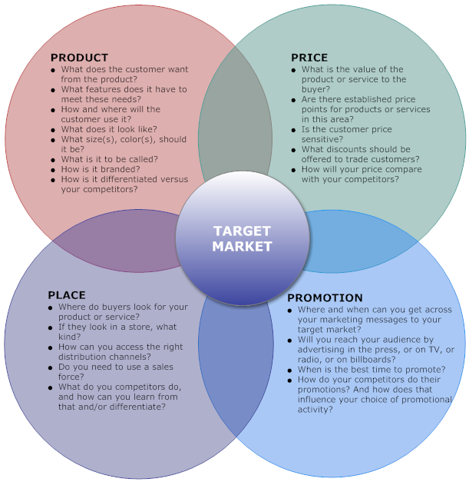

Marketing can also satisfy customer, keep the customer in it and create some customer, has little to do with the service provider and everything can be done with the customer. Great marketing understand what buyer wants or gives it to them and delighting the buyer and consumer to achieve profit or their goal.  
  
  
Why we should study customer relationship? Customer relationship is a term that firmly used to manage and analyze customer interactive and data, with a goal of improving business relationship with purchaser, assisting in the customer retention and sales growth. Customer relationship helps in profiling prospects, enable to understand their need and building relationship with buyer. Moreover, it integrates back and front office system to create database of customer.

**Assignment Questions**

**Examples:**

Assignment question in this part contain 4 questions

**Question 1**

Briefly explain about Marketing in Hospitality and The importance of Hospitality Marketing. (20 Marks)

The meaning of the marketing is effort of a company to grow up their business more by buying and selling a product or services. Most probably in hospitality management, a company definitely will focused their marketing points in the service parts. A simple example that can give in this part is marketing is like the action or activities that always happens in markets. No matter is that mini market, super market, hypermarket, night or morning market but the action or activities that happen in all over here are same such as seller and buyers will meet up to enter into buying and selling transaction. It is an organized trading process. It also including sales and various activities foe exchange of goods and services.

**Marketing Concept**

To which organization goal or target can be achieved by identify and satisfying customer needs, increase sales and income, maximize profits and beat the competition. There are five concept of marketing:

Production

Product

Selling

Marketing

Societal marketing

**Nature of marketing**   
  
Four ways to obtain products are:   
  
- Self- production   
- Coercion   
- Begging   
- Exchange   
  
Self-production   
People can relieve hunger through hunting, fishing, or fruit gathering. In this case, there is no market and no marketing.   
  
Coercion   
Hungry people can wrest or steal food from others. No benefit is offered to the others except that of not being harmed.   
  
Begging   
Hungry people can approached others and beg for food. They have nothing tangible to offer except gratitude.   
  
  
Exchange  
Hungry people can offer a resource in return for food such as money, a good, or service. Marketing appears when people decide to satisfy needs and wants through exchange.   
  
The exchange Relationship  
   
> Exchange is the act of giving up one thing (money, credit, labor, goods) in return for something else (goods, service, or ideas).   
  
>Businesses exchange their goods, services, or ideas, for money or credit supplied by customers in a voluntary exchange relationship.   
  
>The buyer must feel good about the purchase, or the exchange will not continue.   
  
 **Example in hospitality management**

  
  
  
- If your are housekeeper does a good job with on time, and without damage anything, customer will probably feel good about using its services.  
  
-But the services are not good or is not ready on time, customer will probably find other better place to check in.

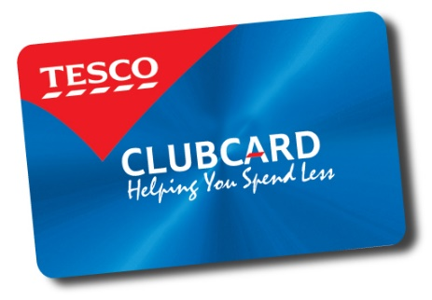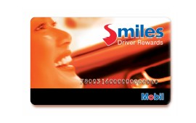**The evolution of marketing**   
Production- Stresses on producing quality products.   
  
Sales- The consumers are not interested and will not but the company’s product unless heavy promotion is done.   
  
Marketing- Companies must identify the needs and wants of target customers and deliver the products to the customers in a better way than the competitors.  
Relationship- A strategy that focuses on targeting long-term partnership with customers by offering value and providing customer satisfaction. Companies will benefit from referrals that lead to increase in sales, market share and profit.  
  
  
**Example**

Relationship marketing goes beyond an effort of making the sale to a drive for marketing the sale again and again. Mesra card, Smiles card, and Tesco Club card are some examples of relationship marketing as an effort for making the sale again and again.  
  
  
Developing a Market Segmentation  
**Identify Market Segmentation**   
  
Market segmentation is the process of separating, identifying, and evaluating the layers of a market in order to identify a target market.  
  
-Market segmentation by age group  
-Fully segmentation market  
-No market segmentation

  
what comes to mind when you hear these terms?   
  
- Geographic   
-Demographic   
-Psychographic  
-Behavioristic   
  
In marketing, these four terms would always be referred to as the variable of market segmentation.  
  
  
  
-1.Geographic segmentation   
Geographic segmentation is where a marketer divides and offer his/her products or services into different geographical units such as states or regions.   
Example, Proton and Perodua cars exported to United Kingdom will have a different version of cars than that is offered in Malaysia.   
  
2. Demographic segmentation  
Divide whole market into small groups such as by (age & life cycle stage, gender, income & occupation)   
  
**-Age & life cycle stage-**  
- Markets can be segmented based on age and life cycle stage differences.

Dutch Lady Marketers several brands, and products of its formula milk targeted to different age segments.

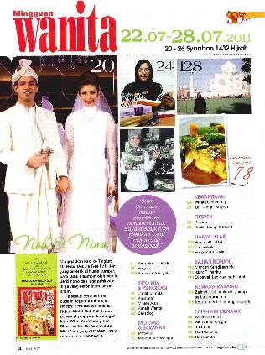**-Gender-**  
Gender has long been used for segmenting markets for clothing, hair dressing products, cosmetics, and magazines. Men and women have different preferences for such products.

“Wanita” magazines are meant for women, “Maskulin” magazines are meant for men.

 **-Income and occupation-**Income level influences consumer’s wants and determines their buying power. Income level indicates their purchasing power.

Proton Perdana are for managers and Perodua Kancil cars are for manual workers.  
  
3. Psychographic segmentation   
Psychographic segmentation divides a market into a various groups such as market into various groups such as social class, lifestyles or personality characteristics. Social class has a strong effect on preferences in cars, clothes, and leisure activities. Lifestyle is the way people lead their lives. Life and the personality of customers can be categorized or segmented on the basis of their ambitions and attitudes such as in being a passive follower or having authoritarian characteristics.   
  
4. Behavioristic   
Product related to behavioral segmentation is dividing a market into groups based on their attitude, use or response to a product.   
  
-Occasions segmentation  
-Benefits sought  
-Loyalty status  
-User status   
  
(Market targeting can be carried out in several ways such as)   
  
-Undifferentiated (Mass) marketing   
-Differentiated (Segmented) marketing  
-Concentrated (Niche) marketing

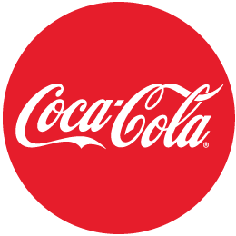  
  
1. Undifferentiated (Mass) marketing   
- Undifferentiated marketing is a market coverage strategy where a firm decides not to do segmentation and offers the market just one item.

Example: The Coco-cola company’s early marketing of only one drink in one bottle size in one taste to suit everyone.   
  
  
2. Differentiated (Segmented) marketing  
-Differentiated marketing is a market coverage strategy in which a firm will have several market segments and divide the market into different groups of customers.   
  
Example: Shoes are sold at different sizes, colors, and design.

3. Concentrated (Niche) marketing   
Concentrated marketing is a market coverage strategy in which firm enters a few and small segments in which they can produce a large share of the market.  
  
  
  
  
  
  
  
  
  
  
  
  
  
  
  
Example: Porsche directs all its marketing efforts towards high-income individuals who want to own high-performance vehicles.

**The importance of hospitality marketing**

The importance of hospitality marketing can be divide into two part as following bellows

|  |  |
| --- | --- |
| **Importance of marketing to the society** | **Importance of marketing to the organization or a company** |
| **-job opportunities**  **-**number of jobless people will decrease  - job vacancies for the fresh graduated/ part time and full time employee /internship student | **-can increase the income**  **-**can develop their business more |
| **-fulfilment or satisfaction of human need**  **-** marketing has great importance in providing goods necessary to fulfill human wants | **-can gain marketing information (latest)**  **-**improve their knowledge in marketing |
| **-economy stabilization**  **-**country will be stable  -rate of money will high | **-company become famous ( known to society)**  **-**become popular |
| **-changes of lifestyle**  **-**improve the standard of living of society | **- decision making**  -help to take right decision in right time in a right way |

;

**Question 2**

Explain the difference between Marketing VS Customer Services.

Explain the Ethics of Marketing and the Customer Service. (20 marks)

**The difference between Marketing VS Customer Service**

|  |  |  |
| --- | --- | --- |
| **Marketing** | **Aspects** | **Customer services** |
| Produces leads and increase sales. | **Advantage the ears on the ground** | Effort to solve the problems |
| Make sure understand all the knowledge and advantage of the products or services. | **Patient** | Don’t wasting the time on purchasing. Give the customer knowledge and fulfilment is important what they should needs. |
| Creating relationship than marketing products or services. Moreover branding and name recognition. | **Relationship** | Create the trust and reliability with customer. Develop the relationship that continually make income for years to come. |
| Should realize that it is time well invested. Important part of marketing a services because time frame able to deliver while still managing and providing services to others. | **Time** | Fully informing customer about the products or services, it will help to avoid the complaints. Additionally happy and smart customer are the better way to improve company reputation and sales. |

There are a lot of ethics of marketing and also a lot of ethics of customer service. Firstly we should know the real meaning of ethic; ethics means the discipline dealing with what is good and bad with moral duty and obligation. Most probably ethic relating to moral principle and also it is all about ‘right and wrong’.

**The ethics of marketing.**

Marketing ethics also all about the things that done or doing by marketer is ‘right and wrong’.

Marketing ethics

1. Marketing effectiveness – the measure of how market’s move on to market strategy is towards reach of maximizing their spending to achieve positive result in both long term and short term
2. Market research – systematic action or process to link the producers, customers, and end users to the marketer through information used identify define the marketing opportunities and problems; evaluate marketing and improve understanding of marketing as a process or systematic action.
3. Marketing management – the action or process of planning and executing the conception, pricing, promotion, and distribution of ideas, goods and services to create exchanges that satisfy individuals and organizational goals.
4. Market segment – a subgroup of people or organization or a company sharing one or more characteristics that cause them to have similar product needs.
5. Market dominance – the strength of a brand, product, services, firm, relative to competitive offerings.
6. Marketing strategy – a action or process or model to allow a company or an organization to focus limited resources on the best chance to improve sales and thereby achieve a sustainable competitive benefits.

Why ethics of marketing is very important?

**Important of the ethics in marketing.**

* To attract the customers
* To increase the sales/profits and improve the business
* To attract the people to join or work in the company for the long term, by this the recruitment cost can be reduce
* To get talented/ skillful employees

**The ethics of customer service in hospitality**

Customer service ethics are almost same as marketing ethics.

1. Utilitarian: the inept greatest good. To have balance of advantages and harms from an action. The ethically right thing that would give the advantage
2. Rights – to make a decision that will best maintain the right of those who are being affected.
3. Fairness – treat the people as fair as can and equally or same.
4. Virtues – become a good human who have moral sense
5. Common good

The ethic that important in the both:

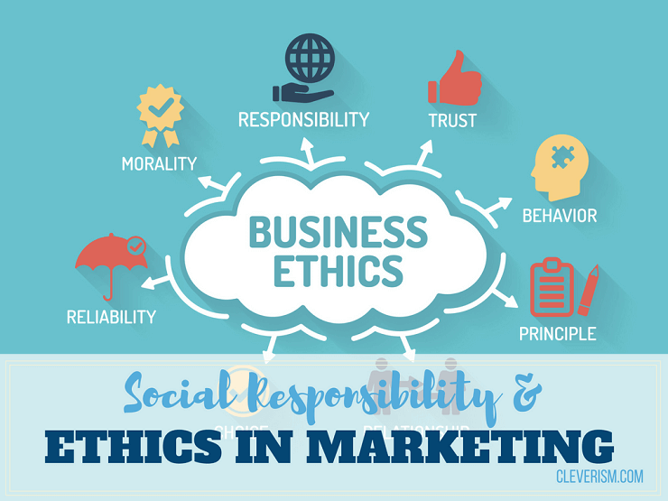

-reliability

-morality  
-responsibility  
-trust  
-behavior  
-principle

**Question 3**

Describe about Marketing strategies and how you can apply your studies in Hospitality Management. (30 marks)

A way or plan to improve something and also to achieve future goal or solution to a problem is called as strategies. Strategies are very important to very single business to improve or develop their business. In hospitality management, marketing strategies is very important to the developments of the business. A good marketing strategy should be drawn from market research and focus on product mix to improve or increase business profit. The marketing strategy is the basis of a marketing plan.

**S.W.O.T Analysis   
S = Strength   
W = Weakness  
O = Opportunity   
T = Threat**A SWOT analysis helps to understanding the strengths and weakness of a company(hospitality) and also opportunities and threats involved in a project or (hospitality) activity.

STRENGTH   
Meaning: The power with the resources, capability, skills, asset, talent, specialty, advantage in relation to the competitor. Strength is under the internal and also positive

WEAKNESS   
Meaning: The condition of lacking strength, the incapability and limitation is the meaning of weakness. Weakness is also under the internal part but negative.

OPPOTURNITIES

Meaning: Opportunities are chance for use something to its advantage. Opportunities is under the external and positive.

THREAT

Meaning: External factor that could jeopardize the project and it’s under the negative.

Example of SWOT Analysis

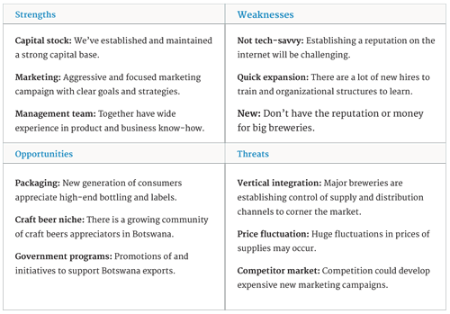

**Marketing-Mix** 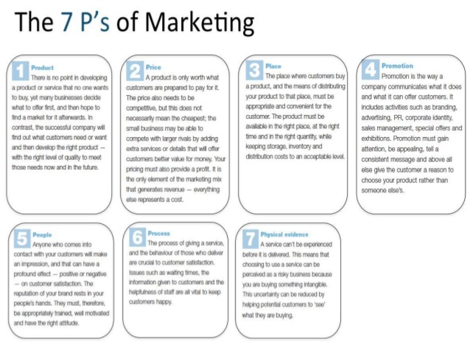

The main marketing-mix is the blend of product offering, pricing, promotional methods, and distribution system that brings to a specific group of Consumers superior value.   
  
-Product  
-Pricing  
-Promotion  
-Place(distributions)   
  
**Product**   
Consumer products can be classified into:   
-Convenience products  
-Shopping products  
-Specialty products

*1.Convenience products*   
- Consumers products are items the consumers seeks to purchase frequently, and immediately. They are inexpensive and are purchased often and with little expenditure of time and effort.   
  
*2. Shopping products*- The product requires comparison shopping effort because the product is usually more expensive than convenience products and found in fewer stores. Consumers usually buy products after comparing several brands or stores based on styles, practically, price, and lifestyles capability.   
  
*3. Specially products*Consumers will search extensively for a particular item and are very reluctant to accept substitutes. Marketers usually use selective, status conscious advertising to maintain product image. The distribution is also limited to one or few outlets in a geographical area.  
  
**Pricing**Price is the amount of money charged for a product or service that consumer’s buy with the exchange for the benefits of having or using the product or service. In hospitality we focused on services.  
  
The four basic categories of pricing objectives:   
- Profitability objectives  
-Volume objectives  
-Meeting objectives  
-Prestige objectives

**Promotion**

**1. Advertising**Advertising is a paid form non-personal communication transmitted through a mass media, such:   
-television commercials  
-online ads  
-magazines advertisements   
  
**2. Sales Promotion**   
Sales promotion are short-term incentives used to encourage consumers to purchase a product or service.  
  
Sales promotion tools:   
-Samples  
-Coupons  
-Cash refunds  
-Patronage rewards  
-Contest, games and sweepstakes   
  
**3. Public Relations**a company will spend a lot on publicity, but normally they do not buy space in magazines or newspapers, television or radio.

|  |  |
| --- | --- |
| Functions | Descriptions |
| Press Relations | Placing positive, newsworthy information in the news media to attract attention to a product, service or company. |
| Public Affairs | Building and maintaining good relationship with the community or local residents. |
| Lobbying | Building good relationship with government officials and legislators. |
| Investors Relations | Maintaining good relationship with investor and the financial community. |

**Place**

-include company activities that make the product to target consumer.  
-the point where product or services are made and available to costumer   
 -access   
 - location  
 - delivery services   
 - electronic delivery

**The following below is the exact and correct strategy planning process.**

1. **Gather facts**

-from all stakeholders

-customer analysis

-competitor analysis

-industry analysis

-environmental

-company performance

-company strategies

**2. SWOT analysis  
 -**external analysis (opportunities and threat)  
 -internal analysis (strength and weakness)  
 -strategic questions  
 -strategic issues

**3. Review inputs  
 -**all stakeholders   
 -review inputs   
 -review SWOT analysis  
 -define 3-4 keys statements

**4. Strategic matrix**  -all stakeholder  
 -define strategies to address SWOT combination

**5. Define strategies   
 -**objectives   
 -key strategies  
 -short/long term goals  
 -operational plans

**6. Review adjustment /final review  
 -**all stakeholder  
 -review strategies   
 -review goals  
 -review plans  
 -adjust as necessary

**Question 4**

Explain in detail on Customer Service Skills and Characteristics.

Explain the Importance of Hospitality Customer Service.

First of all we must understand about the meaning of skills and characteristics. Skills means the capability to do something well and excellent and also known as expertise. At the same time, characteristics bring up the meaning as a typical or noticeable quality of a person. So, from here we can understand about that a person who have good skills and good enough characteristic, can work under the Customer Service line especially in hospitality management. There are a lot of customer service skills and also characteristics. Before that, we should know the importance of customer service skills and also characteristics.

**The example of customer service skills and characteristic**

* **Patience**
* **support**
* **rapid implementation**

**-**those who work under the hospitality management must be patient and control their emotion whenever they handling a customer even the customer be rude (have to find a solution to the problem).

**-**being supportive when the customer confused and frustrated, is also an important thing in hospitality management.

**-**employee must be active in their work place in every single things and all the time and also must be fast and rapid to find a solution if an issue happens in the work place.

**-**for the example**,** employee must be patient when a customer frustrated and come to them (employee) to clear their (customer) doubt, employee must be sure to take right time duration to deal with the customer (work fast and rapid) until what the customer need

* **Attentiveness**

**-**employee must pay attention in their work place especially those who working under hospitality management because paying attention with customer will give a good result and good feedback from the customer side .

- An organization must give importance to be mindful and attentive to the feedback that receive from the group of customer or all the customer, not only paying attention to a indivual customer

-For example, an organization can put a feedback box in front of the hotel or in front of the work place to get the feedback from the customer.

- If good feedback from the customer means make it as strength and if bad feedback means the organization must put some effort to correct it to develop their business.

* **Communication skill**

-communication skill can be divided into two skills;  
 * verbal communication skills  
 * clear communication skills  
 - verbal communication means a person who can communicate with people in multiple language , it is easy to communicate with customer from foreign country, will helpful in reception department to handling or dealing with the foreign customer in hospitality management (hotels).   
 - Clear communication means a person who can convey or express the message or ideas with very clearly and exactly to a person or a group of person, most probably the person who are good in clear communication skill will place or work in handling incoming calls from the customer.

- Otherwise the opportunity are wise to this kind of personality because those who good in communication skills in hospitality management.  
-can work as receptionist to deal customer face to face and also by phone calls  
- can work as waiter or waitress in food and beverage department   
- can work as housekeeper

* **Time management skills**- time management is very important in every organization or management not only in hospitality management.  
  - Time is like a gold, employee cannot wasting customer’s time because it will bring disappoint to the customer.  
  -if the time management is not stable and not good enough means, sure that the business will drop.  
  - For the example, a customer will expect the fast and rapid service from the employee in hotel side (hospitality management) as fast as lightning. If the service are not reached customer’s expectation for sure they will won’t feel satisfied and won’t come again to that hotel in future, and also can be talk bad about the service in social media , it’s also will affect the business developments.

Importance of hospitality costumer service.

-Customer expectation   
 fulfillment customer are looking for a memorable experience and superb services. For guests to leaves a review of their experience on a number of feedback sites. Whatever their experience good or worst. Worst feedback can extremely damaging.

-Deliver on promise   
a company must keep customer happy, but hospitality industry it’s very important to have the guest engaged in order for report business

-Customer royalty  
Always remember happy customer are loyal, which lead to extra mile if need, provide additional items and always tend to impress. Customer are important asset of the business without them what would we have.



**Conclusion**

At the end of this part have finally learned and covered about marketing CNN and customer relationship. How does it applied in hospitality management. The history of marketing as we know it began of a easy way to sell goods or service. To develop communication for selling goods or services has been around the times. Marketing can satisfy customer, keep the customer and create customer, has little to do with the service provider and everything to do with the customer. Customer relationship is a term that firmly used to manage and analyze customer interactive and data, with a goal of improving business relationship with purchaser, assisting in the customer retention and sales growth. It can increase sales, grow business and engage customer. A good marketing strategy create the possibility to achieve their target and goal. Marketing called as sales and customer service that is a tools to carry out the concept. SWOT is a method was originally developed for business and industry. SWOT stands for strength, weakness, opportunities and threat. And the seven P’s of the marketing are product, place, promotion, people, process, price and physical evidence. How it works in hospitality industry. Customer service skill meant to be professional, able communicate, efficiency, positive attitude, listening, patience, good body language, knowledge, handle surprise as well, work under pressure and so on. Customer are the heart of hospitality industry. The quality of services and reliability must be on money. It’s the first point of contact between the hotel guest and the hotel. An opportunity gets to impress and create a lasting great impression. And that's the secret of why nowadays business get a famous act in our in our life as we see. And business people is the richest people in this world and why because business can easily catch up souls so due to that they become the richest one.

**References**

1. Business dictionary (2017) Marketing

• <http://www.businessdictionary.com/definition/marketing.html>

2. Laura Lake ( June 09 2017) What is marketing

• <https://www.thebalance.com/what-is-marketing-2296057>

3. Wikipedia

• <https://en.m.wikipedia.org/wiki/Marketing>

4. James Helton what is marketing strategy.

• <http://www.tronviggroup.com/marketing-strategy/>

5. Tech target customer relationship management

• <http://searchcrm.techtarget.com/definition/CRM>

6. Contributing writer what is customer relation.​

• <http://smallbusiness.chron.com/customer-relations-43230.html>

7. Wikipedia

• <https://en.m.wikipedia.org/wiki/History_of_marketing>

8. Smriti Chand Importance of marketing.

• <http://www.yourarticlelibrary.com/marketing/7-major-importance-of-marketing-marketing-management/25857/>

9. Sharen (Feb 8 2014) marketing definition and importance.

• <https://www.slideshare.net/mobile/sharen1967/marketing-definition-importance>

10. Ivan Dimitrijevic important of marketing.

• <http://www.feedster.com/blog/the-importance-of-marketing-for-business-success/>

11.  [Hitesh Bhasin](http://www.marketing91.com/author/admin/) (April 1 2017) concept of marketing

• <https://www.google.com.sg/amp/www.marketing91.com/concepts-of-marketing/amp/>

12. Business dictionary consideration

• <http://www.businessdictionary.com/definition/consideration.html>

13. Marketing schools ethical marketing.

• <http://www.marketing-schools.org/types-of-marketing/ethical-marketing.html>

14. Supriya Singh (march 3 2014)

• <https://www.slideshare.net/mobile/SUPRIYASINGH12/ethics-in-marketing>

15. Clawtin (Nov 28 2010) marketing ethics.

• <https://www.slideshare.net/mobile/clawtin09/marketing-ethics>

16. Mohit Mahajan ( Jan 17 2016) ethics in marketing

• <https://www.slideshare.net/mobile/mohitmahajan0771/ethics-in-marketing-57147769>

17. Investopedia marketing mix

• <http://www.investopedia.com/terms/f/four-ps.asp>

18. Virginia tan ( Apr 16 2016) customer services ethics

• <https://www.slideshare.net/mobile/VirginiaTran3/customer-service-using-5-ethical-approaches>

19.  Kristie Lorette customer services charateristics

• <http://smallbusiness.chron.com/customer-service-characteristics-756.html>

20.  [Alison Doyle](https://www.thebalance.com/alison-doyle-2058389) (July 07 2017) customer services skills

• <https://www.thebalance.com/top-soft-skills-for-customer-service-jobs-2063746>

21. Surveymonkey improving customer services skills

• <https://www.surveymonkey.com/mp/6-keys-improving-teams-customer-service-skills/>

**Appendix**



Figure 1 Target Market adapted <https://www.google.com/search?q=marketing+mix+7ps+explained&rlz=1C1ASUC_enMY750MY751&source=lnms&tbm=isch&sa=X&ved=0ahUKEwjh3r2_45DVAhWBTbwKHam_AFIQ_AUIBigB&biw=1032&bih=613#imgrc=2YNr22rgr2p20M>:



Figure 2 : Example of SWOT Analysis

https://www.google.com/search?q=swot+analysis+example&rlz=1C1ASUC_enMY750MY751&source=lnms&tbm=isch&sa=X&ved=0ahUKEwiomaT59pDVAhWBbbwKHdn-AIUQ_AUICigB&biw=1032&bih=613#imgrc=5IIZ1YIqT_sxhM:



Figure 3 :The 7 P’s of Marketing   
https://www.google.com/search?q=marketing+mix+7ps+explained&rlz=1C1ASUC_enMY750MY751&source=lnms&tbm=isch&sa=X&ved=0ahUKEwjh3r2_45DVAhWBTbwKHam_AFIQ_AUIBigB&biw=1032&bih=613#imgrc=lui-Elf4M8hNyM: